1. Write a Python Program to Check if a Number is Positive, Negative or Zero?

*def checkNumber(nbr):*

*try:*

*if nbr >= 0:*

*if nbr == 0:*

*print("Given number is Zero")*

*else:*

*print("Given number is Positive")*

*else:*

*print("Given number is Negative")*

*except Exception as e:*

*print(e)*

*checkNumber(0)*

*checkNumber(2)*

*checkNumber(-5)*

*checkNumber("Abc")*

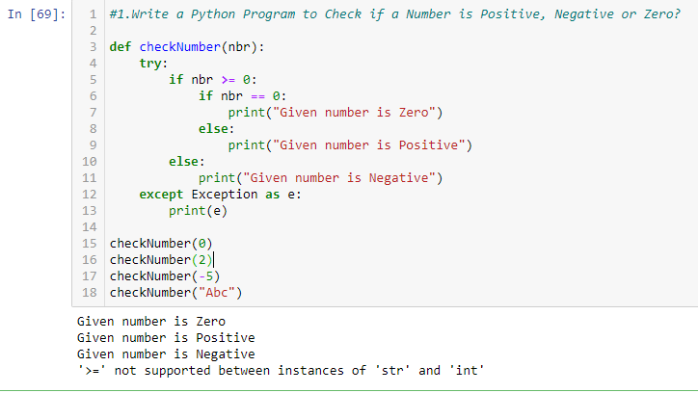

1. Write a Python Program to Check if a Number is Odd or Even?

*def getEvenOdd():*

*num=int(input("Entr a number to validate: "))*

*if (num%2)==0:*

*print( "Given number {0} is Even".format(num) )*

*else:*

*print( "Given number {0} is Odd".format(num) )*

*getEvenOdd()*

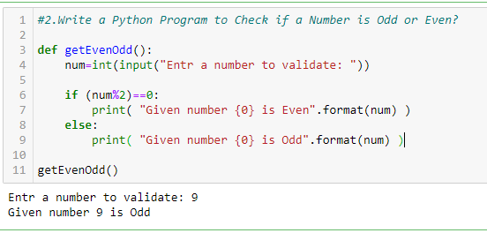

1. Write a Python Program to Check Leap Year?

*def getLeapYr(yyyy):*

*yyyy=int(input("Please enter the year:"))*

*if(yyyy % 400 ==0) and (yyyy % 100==0):*

*print("{0} is a Leap Year".format(yyyy))*

*elif (yyyy % 400 ==0) and (yyyy % 100) !=0:*

*print("{0} is a Leap Year".format(yyyy))*

*else:*

*print("{0} is NOT a Leap Year".format(yyyy))*

*getLeapYr(2022)*

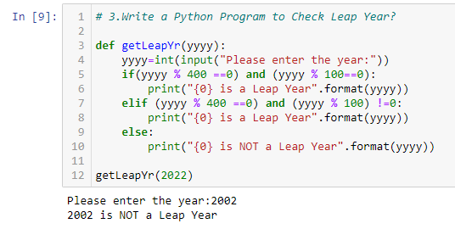

1. Write a Python Program to Check Prime Number?

*def checkPrime(num):*

*if num > 1:*

*for i in range(2, int(num/2)+1):*

*if (num % i) == 0:*

*print(num, "is not a prime number")*

*break*

*else:*

*print(num, "is a prime number")*

*else:*

*print(num, "is not a prime number")*

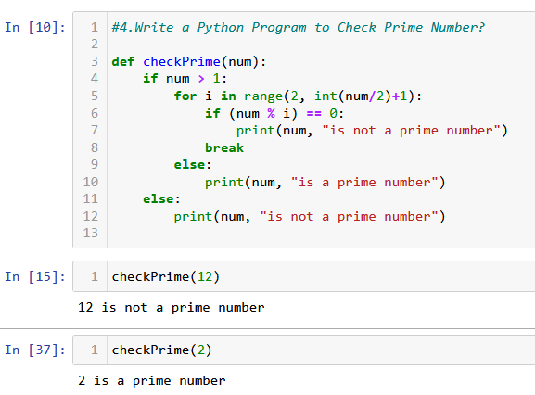

1. Write a Python Program to Print all Prime Numbers in an Interval of 1-10000?

*def checkPrimeNumber(stdNbr,endNbr):*

*print("Prime numbers between", stdNbr, "and", endNbr, "are:")*

*for num in range(stdNbr, endNbr + 1):*

*# all prime numbers are greater than 1*

*if num > 1:*

*for i in range(2, num):*

*if (num % i) == 0:*

*break*

*else:*

*print(num)*

